**Hi Everyone,**

# **Date** St Margaret Mary’s 17th March 2022

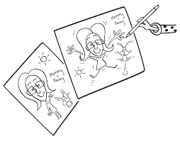  
  
** **Big Art Comp is starting this week**

The Big Art Comp runs from 7 – 20 March

Children need plenty of opportunities for creative play and creative thinking. We start by providing activities that are based on the children’s interests and ideas. Being creative is more than drawing or painting, there is also photography, music, working with wire, clay paper, wood, water, and shadows, the possibilities are endless. Creativity is a form of self-expression and the ability to be creative, to create something from personal feelings and experiences, can reflect and nurture children’s emotional health. Creative activities acknowledge and celebrate children’s uniqueness and diversity.

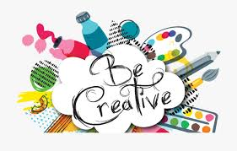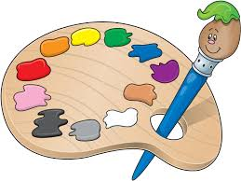Please phone Camp Australia 1300-105-343 for bookings, **rebates will apply.**

**To find out more about the program, view fees and to register, visit**

[**www.campaustralia.com.au**](http://www.campaustralia.com.au)

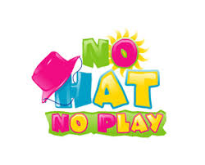Keep Smiling 😊 Louise & Jenny

The children have been cleaning up the school yard this week, celebrating Clean Up Australia Day. They all did a great job 😊 We have been doing lots of great cooking recipes from our Healthy OSHC Cookbook, Cheesy Nan, Corn Fritters, Flat Bread, Honey Crackles, Sponge Cake, and Pancakes. We had Games week this week and the children learnt a new card game together called Bags and War Lords, they all really enjoyed playing the game.



