Uniform Shop Price List
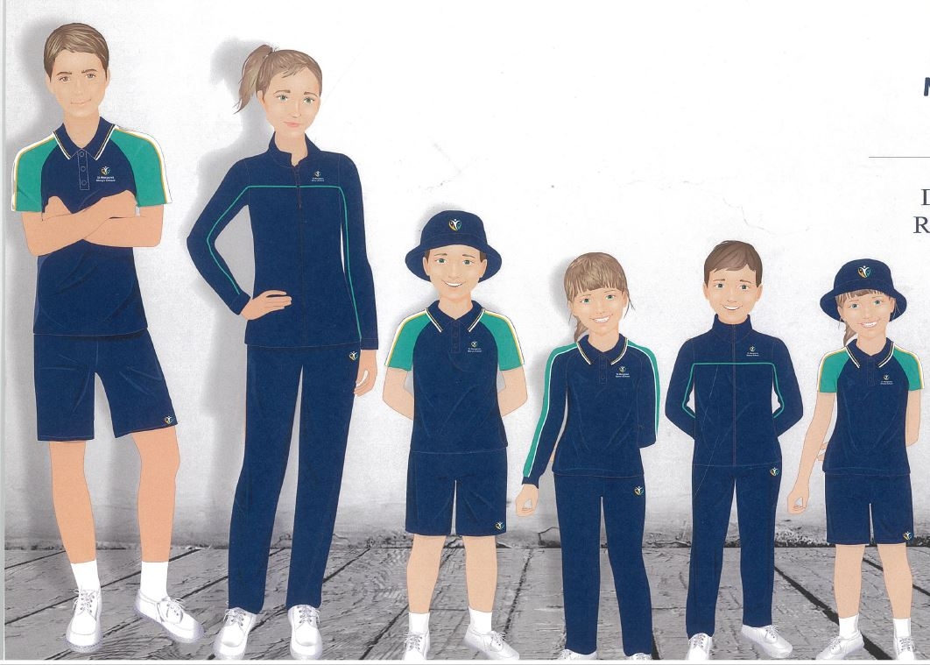
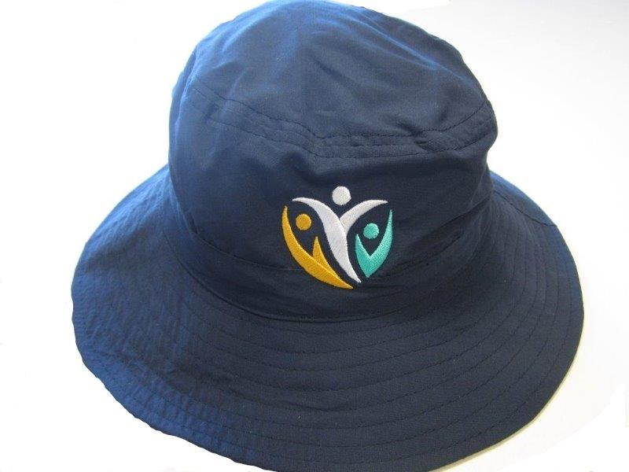
Opening Hours: Tuesday 2.30-3.30pm; Friday 8.30-10.00am

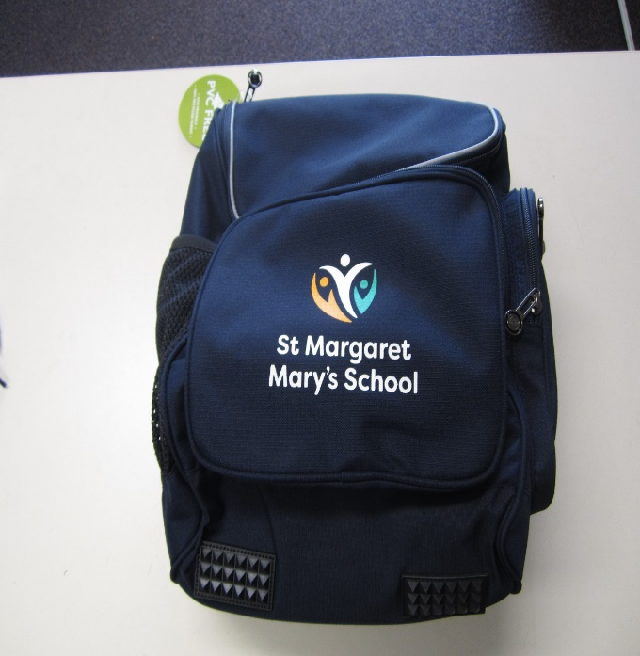
Short Sleeved Polo Top $40
Long Sleeved Polo Tops $40
Shorts $30
Track Pants $50
Jackets $60
Hats $20
Bags $60
Knee Pads for track pants $7ea
Beanies $15

