School Performance Report 2021
St Margaret Mary’s School

St Margaret Mary’s School performance report is a celebration of the learning, achievements and community in 2021. We have been guided by our Strategic Directions (included at the end of this report) to work collaboratively with parents/carers to provide a high-quality education and wellbeing program with students at the heart of everything we do.
School Context
St. Margaret Mary's School and Preschool is a Catholic school situated in the western suburbs of Adelaide. We offer a comprehensive education program to students from diverse backgrounds. Based on the Josephite tradition and the core values of integrity, compassion, responsibility, perseverance and justice. We are a multicultural school that works closely with parents and the community to celebrate and embrace our diversity and share our common vision to foster a love of learning and service to others.
The school was founded in 1928 and has been completely rebuilt over the past 2 years, enabling us to offer a contemporary and attractive 21st century learning environment. A Middle School unit offers a flexible learning space and programs that meet the educational and social needs of early adolescent students. We have a contemporary purpose-built Preschool, along with a multi-purpose hall and instrumental music rooms. The Preschool caters for the specific learning needs of four-year children, while the multi-purpose area complements the school's Performing Arts curriculum. The school has a strong curriculum focus on Religious Education, Literacy, Numeracy, Student Wellbeing and the needs of English as Additional Language learners. All students from Reception to Year 6 are given the opportunity to learn the language and culture of Italy through a dynamic Italian curriculum.
2021
During 2021 we continued to be flexible and adapt to the changing circumstances of the COVID-19 global pandemic. We worked through changes to restrictions and a state-wide lock down. The restrictions meant that some of our events were ‘reimagined’, with reduced capacity for parent involvement in many activities. The school activities are outlined in the accompanying Principal Report.
Our community continued to work around our extensive building program in 2021 and I am pleased that practical completion was achieved early in 2022. The project cost approximately $5.25 million with $1 million funded through a Federally funded capital grant. This project has transformed our learning spaces and achieved our goal of bringing our school together geographically. It has allowed classes to work flexibly with mobile technology and caters for small groups and spacious, light-filled classrooms.
Staff at St Margaret Mary’s School continued to deepen their understanding of the maths curriculum in ongoing professional learning with the Primary Maths Association. Literacy is a strong curriculum focus with intervention programs for Year 1 students and MacqLit for Year 3-6s. We have a teacher who specialises in supporting students with English as an Additional Language and all staff understand the needs of these students and plan and teach accordingly.
Students with additional needs are supported in many ways. Personalised Plans for Learning are prepared for children who require adjustments to their learning. These adjustments range from quality differentiated teaching practice to 1-1 support inside and outside the classroom. We offer a wellbeing program that includes a school counsellor, What’s the Buzz? Social skills groups, mentoring and Drumbeat.
St Margaret Mary’s Preschool continues to thrive and is supported by a vibrant Playgroup and Occasional Care program. These programs allow our children to engage in quality Early Years education in a familiar and purpose-built environment. The children then transition easily to the primary school setting. In 2021, we offered a Term 3 intake for both Preschool and Reception/Foundation.
St Margaret Mary’s School continued to work with the Croydon Park Parish and the other schools within our Parish (Whitefriars School and St Patrick’s School). Our senior students, along with Whitefriars School, participate in the Journey to Emmaus Program. Staff from the three schools work with the Parish Sacramental Coordinator to support the Sacramental Preparation Program.
St Margaret Mary’s school is an active member of the Catholic North Western Community. We have a clearly articulated Identity Statement and belief that by creative collaboration we can value add to each other’s community and so deepening students learning opportunities and outcomes, staff expertise and services for our whole community. Staff are connected with other Educators in the Catholic North Western Community through network meetings and professional learning opportunities.
2021 NAPLAN
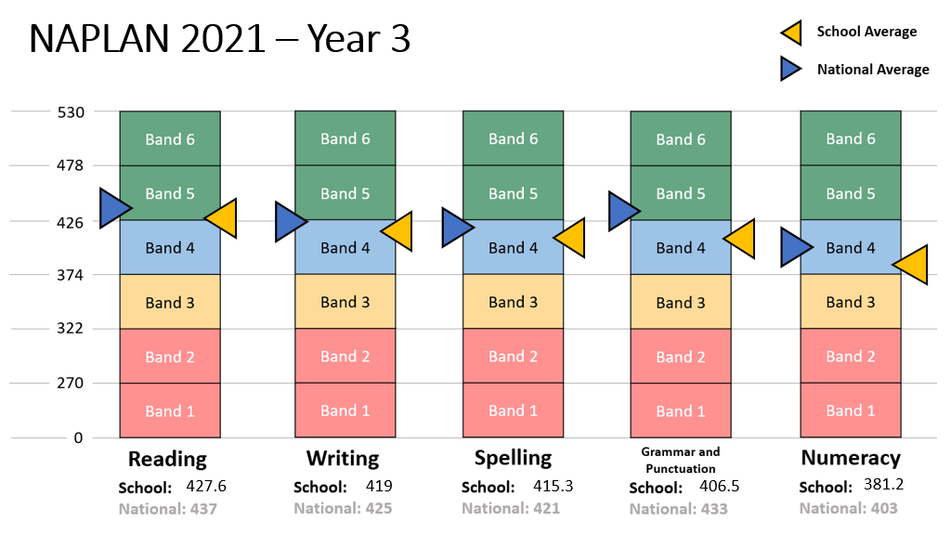

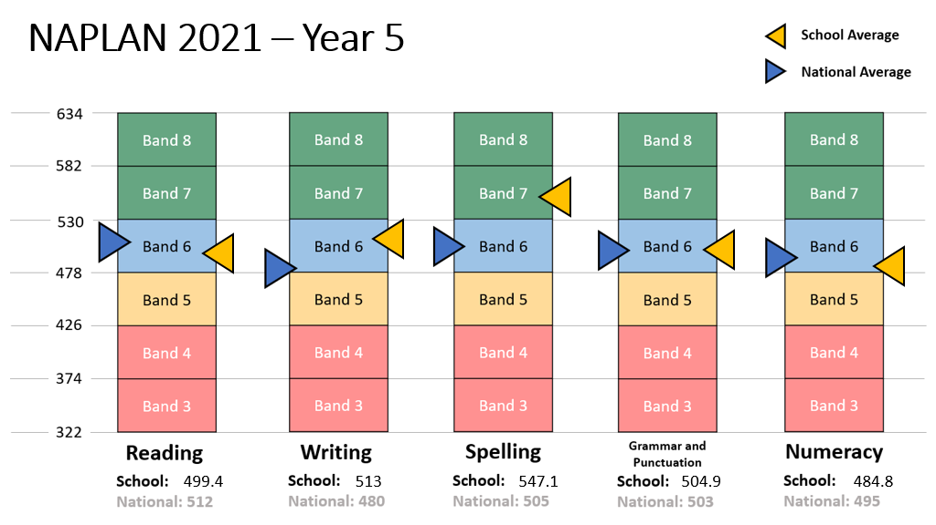

Living Leading Learning Survey
In 2021, our community participated in the LLL surveys. We were very pleased with the level of engagement from staff, students and parents. The feedback has been an important factor in developing our 2022 Annual Improvement Plan.
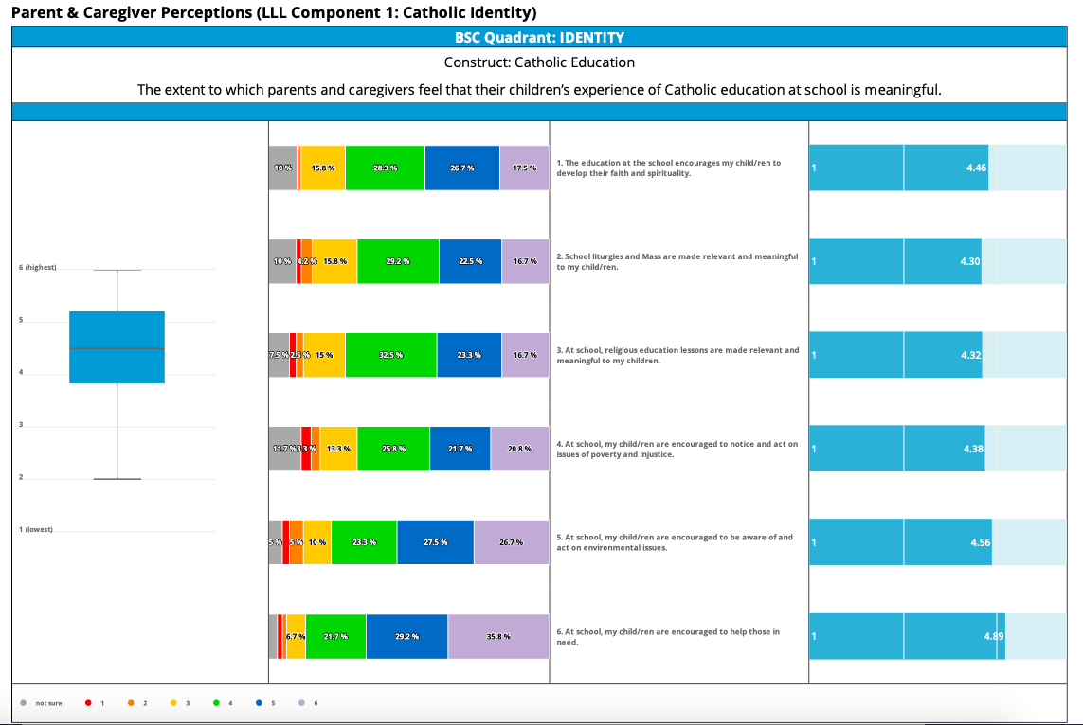

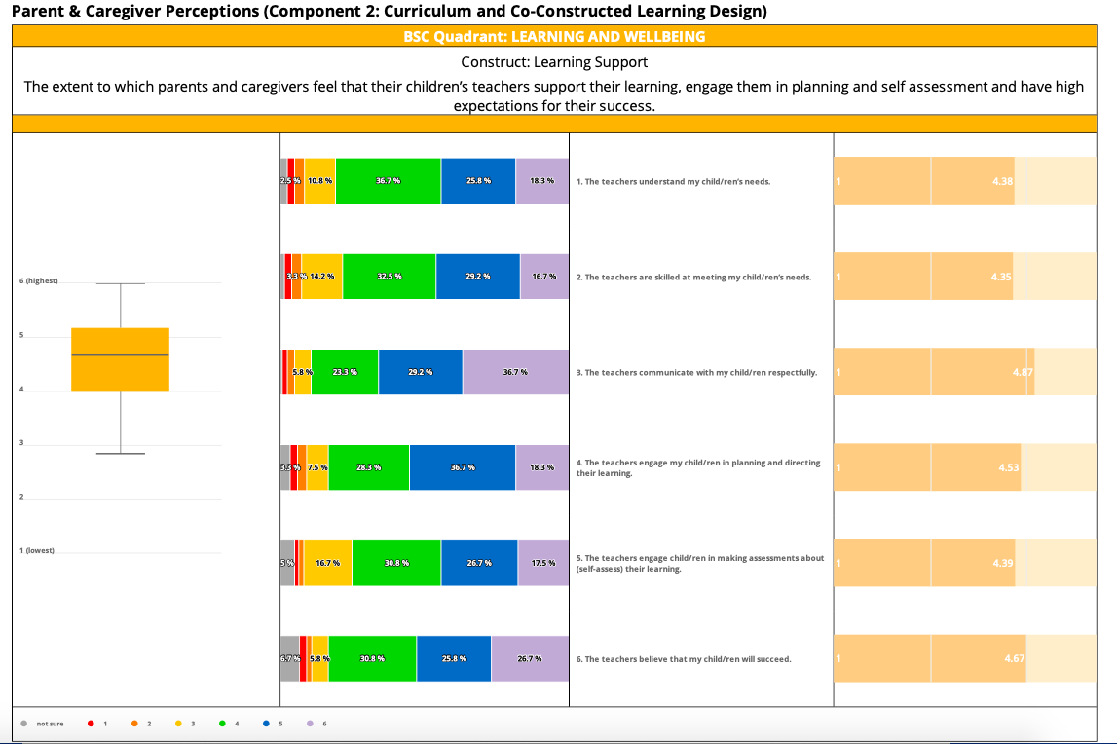
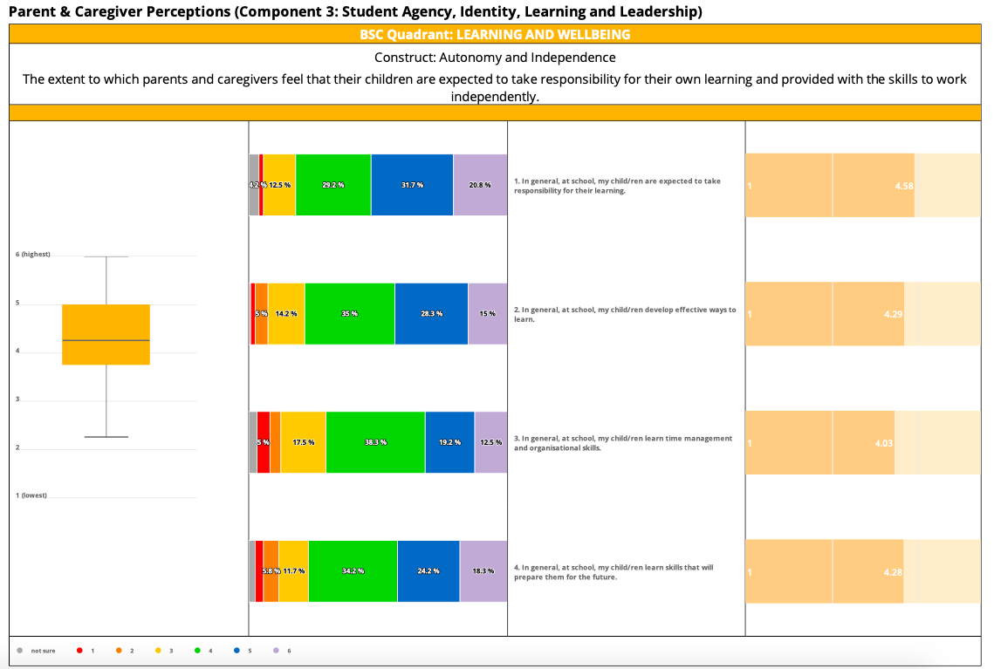

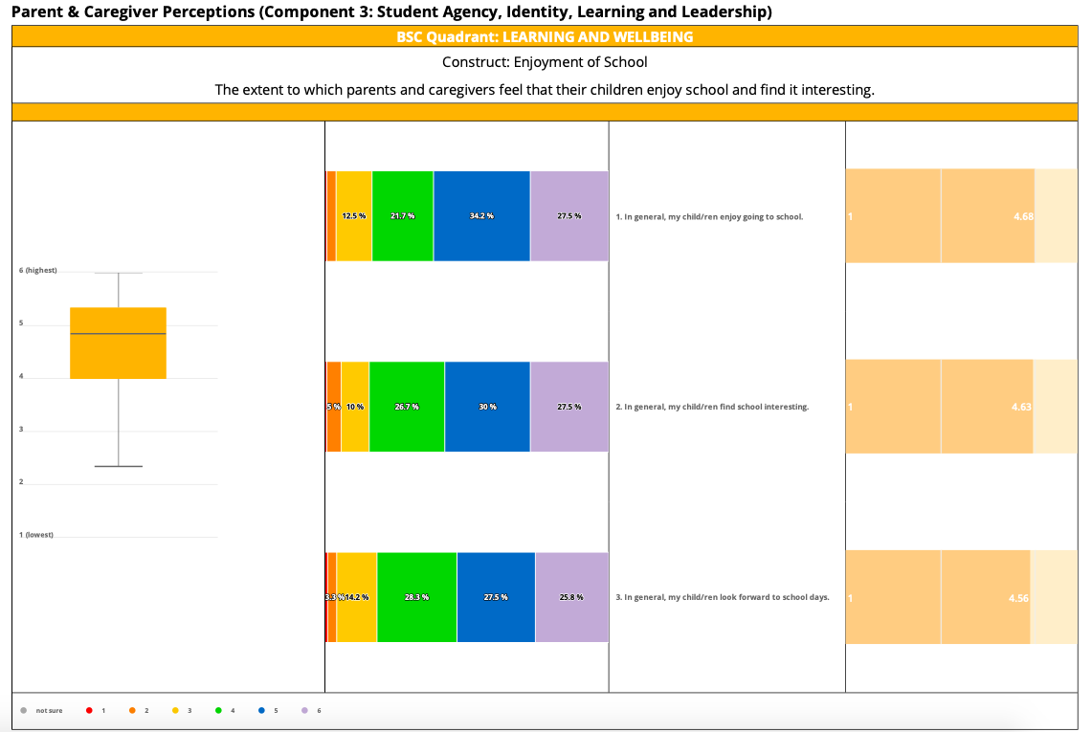

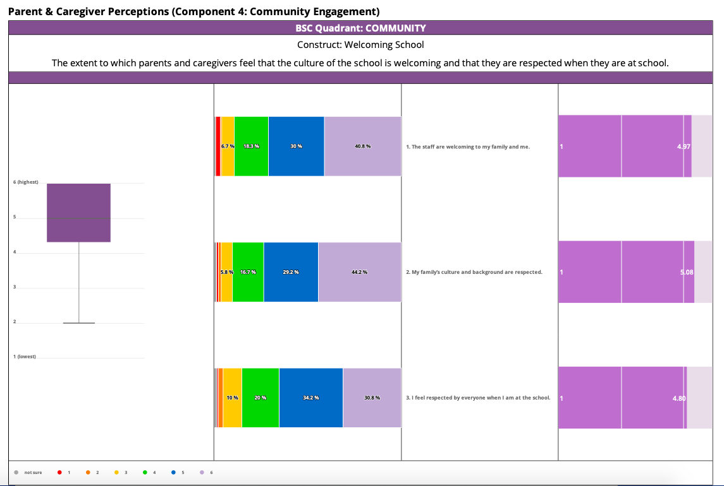

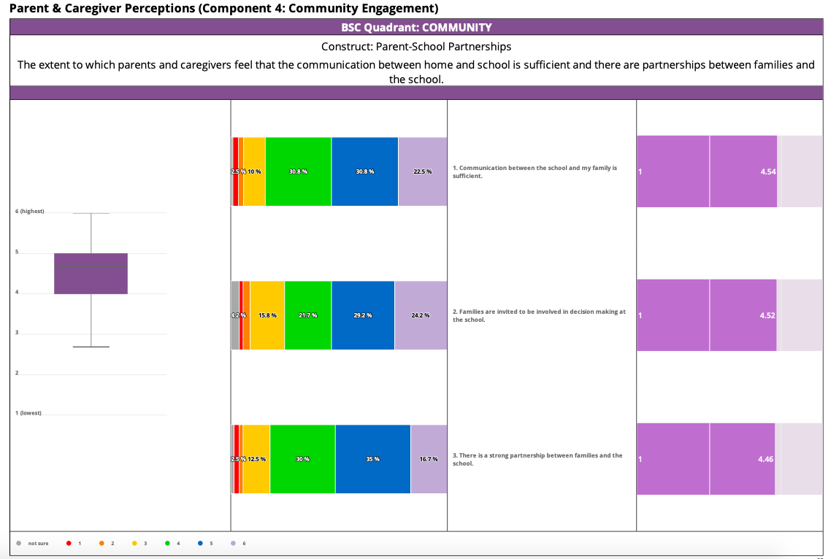

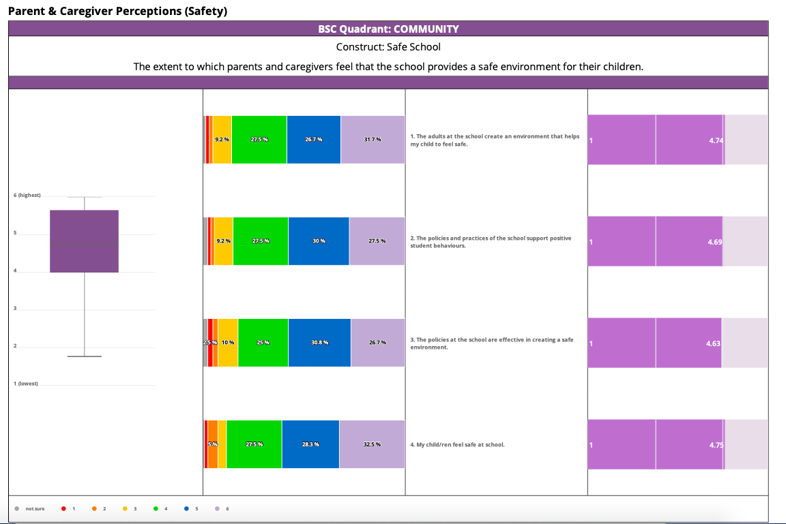

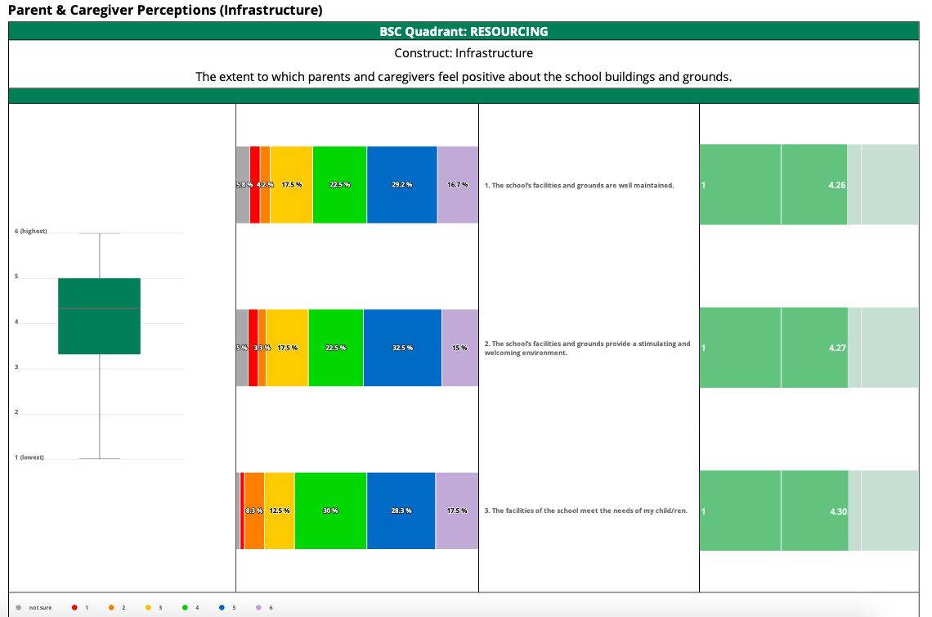

2021 SCHOOL YEAR
The 2021 school financial audit will be completed by KPMG who are auditing every Catholic school and entity in SA. Once finalised our audited Annual Financial Statement will be sent to the Catholic Education Office as required.
Our Building Program commenced in March 2020.
Building Project: $5.25 million made up of
$1m – commonwealth government capital works grant
$2m loan – through Catholic Development Fund
$2.25 school contribution
In 2020 we received our government grant and paid our school contribution so commenced the draw downs on our loan in 2021.

SES 91
STUDENT PROFILE (from July 2021 Commonwealth Government SA Census)
Total enrolments R – Year 6
YEAR | Rec | Yr 1 | Yr 2 | Yr 3 | Yr 4 | Yr 5 | Yr 6 | TOTAL
BOYS | 38 | 24 | 19 | 20 | 12 | 12 | 22 | 147
GIRLS | 30 | 21 | 19 | 26 | 24 | 15 | 18 | 153
TOTAL | 68 | 45 | 38 | 46 | 36 | 27 | 40 | 300

Indigenous students 4
Preschool enrolments (term 3 annual census) 44
Nationally Consistent Collection of Data Students 74 (mid year census)
QDTP 21 students
Supplementary 40 students
Substantial 13 students
Funded students with disability as a % supplementary and substantial 18% (mid year census)

Teacher Standards and Qualifications in 2020
Diplomas/Advanced Diplomas 50%
Bachelor Degree in Education 100%
Graduate Certificates 46%
Masters Degree in Education 17%
Certificate in Education 46%

STAFF PROFILE
Workforce composition
R-6 teaching staff Total 22 Full time equivalent 17.9
Non-Teaching staff Total 12 Full time equivalent 6.1
Staff who identify as Indigenous 0
Preschool Teaching staff 3 Full time equivalent 1.2
Preschool Non-Teaching staff 1 Full time equivalent .8

School open 183 days out of a possible 193
5 school closure days due to COVID when we were open for our children of essential workers and our vulnerable children.

STUDENT ATTENDANCE in 2021
YEAR LEVEL | TERM 1 | TERM 2 | TERM 3 | TERM 4
REC | 92.59 | 90.54 | 92.77 | 92.24
YEAR 1 | 93.62 | 91.35 | 93.49 | 91.59
YEAR 2 | 96.11 | 93.73 | 93.21 | 91.76
YEAR 3 | 95.38 | 94.38 | 94.9 | 93.9
YEAR 4 | 95.61 | 95.82 | 95.97 | 95.37
YEAR 5 | 94.87 | 94.3 | 94.3 | 90.92
YEAR 6 | 94.26 | 93.9 | 94.88 | 95.49
TERM AVERAGE | 94.63 | 93.43 | 94.2 | 93.03

Average attendance for the 2021 school year was 93.82%

Secondary school destinations for Year 6 students
School Destination for Year 6 students | TOTAL
Nazareth Catholic College | 12
Christian Brothers College | 2
Mount Carmel College | 11
St Dominic’s Priory College | 1
Blackfriars Priory School | 2
Our Lady of the Sacred Heart College | 1
Woodville High | 2
Glenunga International School | 1
Adelaide High School | 1
St Michaels College | 1
Islamic College | 1
Temple Christian School | 2
Adelaide Botanic High | 2

